38.11: a) The work function 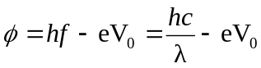
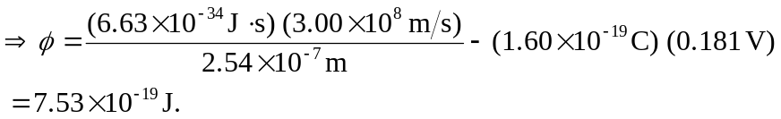
The threshold frequency implies 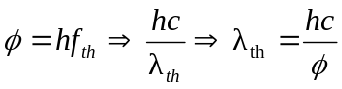
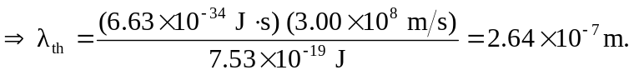
b) 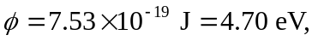 as found in part (a), and this is the value from Table 38.1.

